ASP.NET Core 8.0 Web API

4. Web API Hands on

1. Objective
To implement an HTTP PUT operation in an ASP.NET Core Web API to update an existing employee record using an employee ID and an updated Employee object received through the request body.

2. Software / Tools Used
- Visual Studio
- ASP.NET Core Web API
- C#
- Swagger UI

3. Procedure

3.1 Employee Data
A hardcoded list of Employee objects was maintained in EmployeeController. The employee list contains employee details such as Id, Name, Salary, Permanent status, Department, Skills and DateOfBirth.

3.2 Implementing the HTTP PUT Method
A PUT action method was added to EmployeeController. The employee ID is received through the route and the updated Employee object is received from the request body using the [FromBody] attribute. The method validates the employee ID, searches the hardcoded employee list, updates the matching employee properties, and returns the updated employee using ActionResult<Employee>.
PUT endpoint:
[HttpPut("{id}")]
Update method structure:
public ActionResult<Employee> UpdateEmployee(
int id,
[FromBody] Employee updatedEmployee)
{
if (id <= 0)
{
return BadRequest("Invalid employee id");
}
var employee = employeeList
.FirstOrDefault(e => e.Id == id);
if (employee == null)
{
return BadRequest("Invalid employee id");
}
employee.Name = updatedEmployee.Name;
employee.Salary = updatedEmployee.Salary;
employee.Permanent = updatedEmployee.Permanent;
employee.Department = updatedEmployee.Department;
employee.Skills = updatedEmployee.Skills;
employee.DateOfBirth = updatedEmployee.DateOfBirth;
return Ok(employee);
}

4. Testing Using Swagger
The API was executed and the PUT endpoint was tested using Swagger UI.

4.1 Valid Employee ID Test
The PUT endpoint was called using employee ID 1 with updated employee details. The employee name was changed to John Updated and the salary was changed to 70000.
Request URL: https://localhost:7009/api/Emp/1
Response: 200 OK
The response body returned the updated Employee object successfully.

4.2 Invalid Employee ID Test
The PUT endpoint was tested with an invalid employee ID of 0. The API validated the ID and returned a Bad Request response.
Response: 400 Bad Request
Response message: Invalid employee id

5. Verification Results
Test Case | Expected Result | Observed Result
Valid ID = 1 | Employee details updated and 200 OK returned | Successfully updated John to John Updated and salary to 70000
Invalid ID = 0 | 400 Bad Request with Invalid employee id | Successfully returned 400 Bad Request
Request body | Updated Employee object accepted using [FromBody] | Successfully received and processed Employee JSON
Return type | Updated Employee returned using ActionResult<Employee> | Successfully returned updated Employee object

6. Screenshots
Figure 1: Swagger PUT request for employee ID 1 showing 200 OK and the updated employee details.
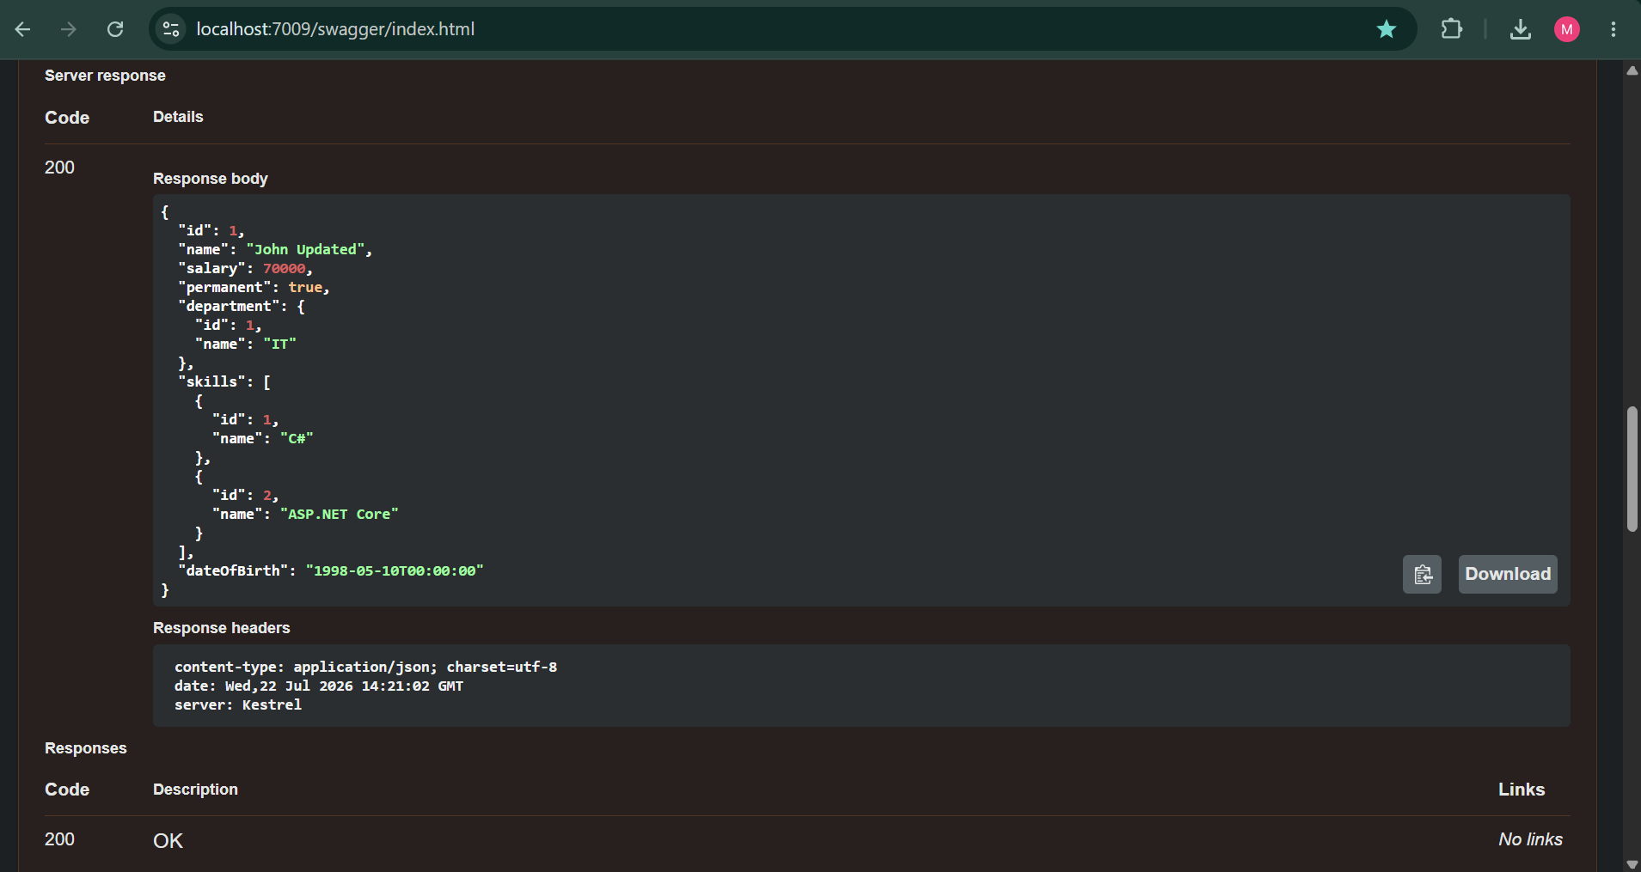

Figure 2: Swagger PUT request for invalid employee ID 0 showing 400 Bad Request and 'Invalid employee id'.
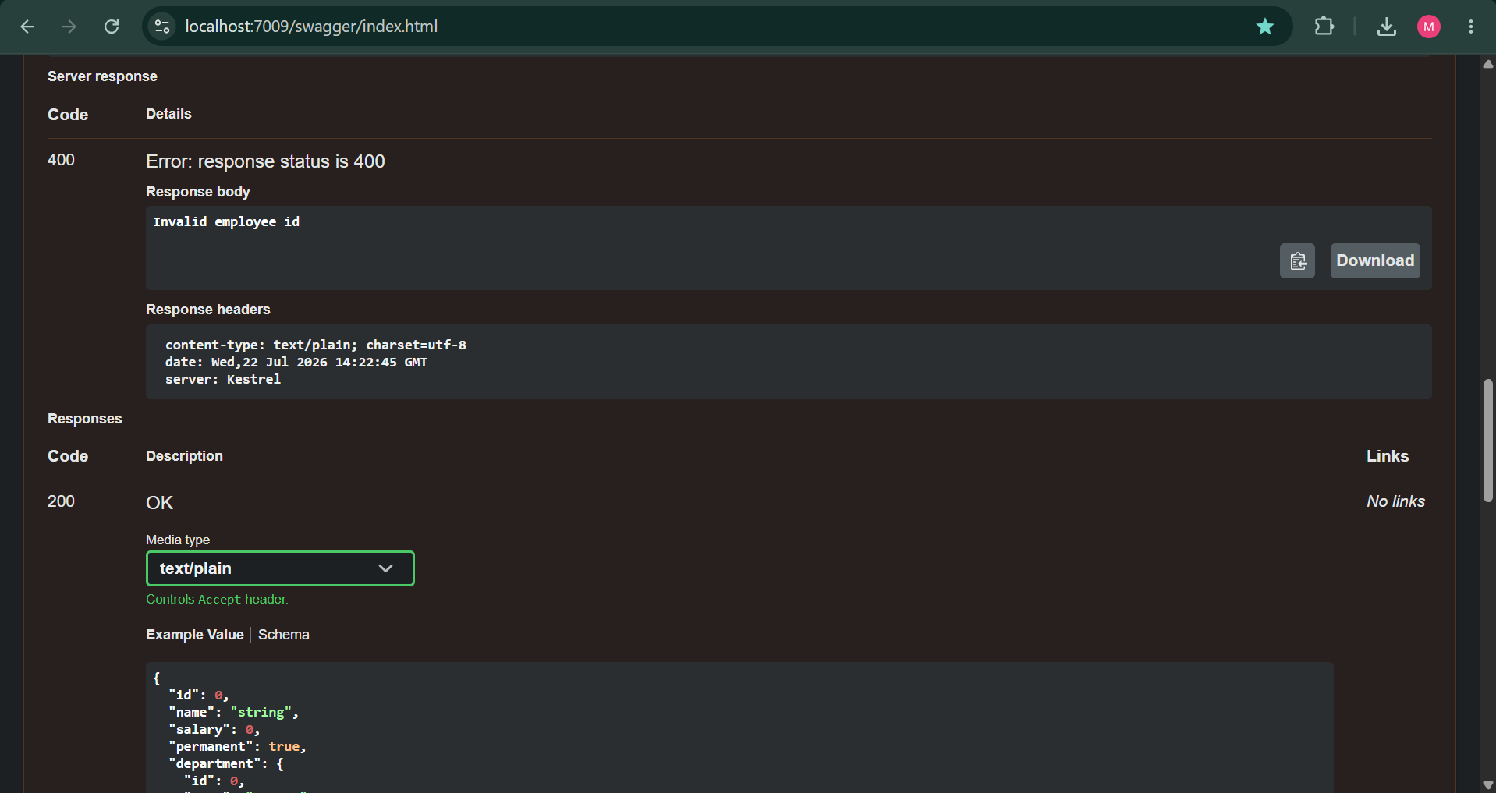

7. Result
Successfully implemented the HTTP PUT operation in an ASP.NET Core Web API to update employee details. The API accepts the employee ID through the route and the updated Employee object through the request body using [FromBody]. A valid employee record was successfully updated and returned with a 200 OK response. Invalid employee IDs were correctly handled with a 400 Bad Request response.

